Title: The Alpine Germination Syndrome differs between temperate and Mediterranean habitats

Abstract (max 300 words)
- Aims: Recently, alpine communities have shown changes in plant composition, potentially influenced by alterations in their reproductive fitness. Understanding the environmental cues that stimulate germination is therefore important for forecasting future impacts. Although general germination patterns have been described in alpine plants, their ecological determinants can be highly species- and context-specific. Here we ask whether germination responses to environmental cues differ across alpine habitats and related communities in a climatically heterogeneous region.
- Location: Cantabrian mountains (northwestern Spain).
- Methods: We examined four germination cues in 56 species from contrasting Mediterranean and temperate alpine habitats. We subjected the seeds to five months of cold stratification, mimicking snow-like conditions, and recorded their germination. Using the remaining non-germinated seeds, we tested the effects of water limitation, darkness, and constant temperatures on final germination compared to control conditions.
- Results: Seed germination responses to cold stratification differed between habitats, with species from the Mediterranean habitat exhibiting significantly higher germination during stratification than those from the temperate habitat. Species from both habitats responded similarly to the other treatments: lack of water and light hindered germination.
- Conclusions: Our results open the door to new germination strategies linked to multiple climatic variation occurring in alpine habitats worldwide. Although germination requirements are species-specific, they are also modulated by macro- and micro-climatic conditions, determining climatic-driven shifts in community composition. In warmer conditions with reduced snow cover, species that require short periods of cold stratification and can tolerate limited water availability are likely to be favoured.

Keywords (8-10): Germination syndromes, Alpine regeneration, Alpine grasslands, Snow cover, Water limitation, Germination cues, Seed germination, Temperate habitat, Mediterranean habitat.

Introduction
Alpine communities are subjected to high solar radiation, strong winds, below-zero temperatures and snow cover, factors that limit the length of the growing season for plant development and regeneration (Körner 2021). Under ongoing climate change, with warmer temperatures (Nogués Bravo et al. 2008) and a redistribution of monthly rainfall (Sillmann et al. 2013), alpine plants will need to adapt their reproductive phenological cycle (Walck et al. 2011; Mondoni et al. 2012), including reproductive performance (Notarnicola et al. 2022), flowering time (Briceño, Hoyle, and Nicotra 2015), and germination (Milbau et al. 2009; Espinosa del Alba, Fernández-Pascual, and Jiménez-Alfaro 2024). To maximise regeneration during the appropriate time and place, regulation of germination is a key process driven by the interactive effects of environmental cues, mainly related to water availability and temperature (Donohue et al. 2010; Baskin and Baskin 2014). Seed adaptation to these cues maximises germination success, avoiding freezing in winter and early frost spells in spring (Fernández-Pascual et al. 2021).
Temperate alpine floras tend to show a cold-adapted temperate germination syndrome (Fernández-Pascual et al. 2021). This is characterised by a requirement for long periods of cold-wet stratification to relieve physiological dormancy (Shimono and Kudo 2005; Schwienbacher et al. 2011; Margreiter et al. 2020), optimal germination at relatively warm temperatures (Baskin and Baskin 2014), and increased germination under light (Mondoni et al. 2009) and alternating temperatures (Fernández-Pascual et al. 2021). The requirement for cold stratification prevents precocious germination under autumn conditions, where optimal conditions are unlikely to persist (Cavieres and Arroyo 2000). Thus, germination is postponed until a more favourable period after snowmelt, when optimal conditions of water availability and temperature requirements are met (Cavieres and Arroyo 2000; Walder and Erschbamer 2015). These conditions are mainly modulated by microtopographic diversity, producing highly variable temperatures and humidity with potential impacts on germination responses (Espinosa del Alba, Fernández-Pascual, and Jiménez-Alfaro 2024).
There is evidence that temperate alpine species depart from the general cold-adapted germination requirements previously described (Schwienbacher et al. 2011; Orsenigo et al. 2015), including within and between-habitat variation (Tudela-Isanta et al., 2018, Rosbakh et al., 2022). A particular case has been described for high-elevation areas under Mediterranean-climate influence. In general, the germination of Mediterranean species responds positively to relatively cold temperatures, darkness, and constant temperatures (Cruz-Tejada et al. 2024). There, seed dormancy is primarily regulated by after-ripening strategies that facilitate germination during the rainy season (Baskin and Baskin 2014), an adaptation to maximise the length of the growing season before the onset of summer drought (Doussi and Thanos 2002). Studies on central Iberian mountains revealed that some species are ready to germinate shortly after dispersal (with low or no requirement for cold-wet stratification), thus synchronising seed regeneration with autumn rainfall (Picciau et al. 2019), while other species germinated as typical alpine species (requiring cold-stratification) (Giménez-Benavides, Escudero and Pérez-García, 2005). These results suggest an intermediate response between cold and drought-adapted germination syndromes in Mediterranean-influenced climates. Although this indicates that individual species adapt to local conditions, we know little about the ecological drivers shaping these strategies and the potential role of water limitation in the germination of alpine species in both temperate and Mediterranean climates. Recently, it has been suggested that water availability may play a more significant role than expected in the germination of alpine species (Mondoni et al. 2022; Espinosa del Alba et al. 2025). However, germination experiments on alpine species are generally conducted under conditions of water saturation in laboratory experiments, and there is a lack of information about moisture ranges for germination in alpine climates.
Water availability in alpine areas is primarily linked to regional precipitation regime, which is expected to vary strongly across mountain regions globally (Testolin, Attorre, and Jiménez-Alfaro 2020). In addition, soil water content depends on the spatial and temporal distribution of snow cover, which also has an indirect impact on soil temperature (Decker et al. 2003), thereby acting as an important cue for germination. Some alpine species can germinate under snow-like conditions (Schwienbacher et al. 2011; Cavieres and Sierra-Almeida 2018; Fernández-Pascual et al. 2021), protecting seeds and seedlings from freezing temperatures and increasing soil moisture, therefore extending the growing season (Briceño, Hoyle, and Nicotra 2015). While most germination studies use a cold-wet stratification period for breaking seed dormancy of alpine species (usually temperatures selected close to 4ºC), very few mimic real under-snow conditions (0-0.5 ºC and darkness) (Shimono and Kudo 2005; Milbau et al. 2009), and few studies have addressed the potential effects of moisture (Gya et al. 2023; Espinosa del Alba et al. 2025). It is known that water limitation has a consistent negative effect on germination (Walck et al. 2011; Orsenigo et al. 2015; Vázquez-Ramirez and Venn 2021), but we do not know whether alpine species can germinate under different levels of water stress. Considering that warmer temperatures seem to increase germination (Vázquez-Ramirez and Venn 2021), the potential effects of alpine warming on alpine regeneration will likely depend on water availability, especially in regions with lower precipitation regimes (Mondoni et al. 2022).
In this study, we analyse germination cues related to temperature and water availability in alpine species from a mountain region of the Iberian Peninsula with both Mediterranean and temperate alpine habitats. By sampling contrasting communities representing temperate and Mediterranean alpine habitats, we evaluate how key environmental cues influence the germination niche of species adapted to both climatic conditions. Using the same study region also allows us to compare species from a regional flora subjected to similar evolutionary and ecological constraints. First, we investigated germination responses to cold stratification by mimicking snow-like climatic conditions, with the hypothesis that species from alpine temperate habitats will show lower germination during cold stratification, due to their requirement for warm temperatures, following the general cold-adapted germination syndrome. Secondly, we tested germination responses to water limitation, with the hypothesis that species from the Mediterranean habitat will germinate better than those from the temperate habitat, due to higher selective pressure to thrive under water-limited conditions. We also analysed germination responses to darkness and constant temperatures to account for additional cues known to influence germination in herbaceous species. However, we did not expect significant differences between habitats, as both are open mountain grasslands hosting similar functional plant communities.

2. Materials and Methods

2.1 Study area
We investigated alpine communities occurring between 1900 and 2500 m a.s.l. in the Cantabrian Mountains, northwestern Spain. This area is a transitional biogeographical zone between Eurosiberian and Mediterranean regions in Europe, allowing for the coexistence of temperate and Mediterranean mountain floras (García-Gutiérrez et al. 2018; Jiménez-Alfaro, Abdulhak, et al. 2021). Our study focused on two habitats: (1) temperate alpine grasslands, and (2) Mediterranean alpine grasslands (Table 1, Figure 1). The temperate alpine habitat exhibits high-diversity grasslands and swards on calcareous bedrock (Jiménez-Alfaro et al. 2014), mainly dominated by Carex sempervirens. In the study region, temperate alpine habitats are restricted to higher altitudes and wetter areas in the northern slopes of the Cantabrian Mountains, especially in the Picos de Europa National Park. Conversely, the Mediterranean alpine habitat occurs on acidic bedrock and features lower plant diversity dominated by regional endemics like Luzula caespitosa and Festuca summilusitana. The two habitats experience a cold, wet winter, but only the Mediterranean habitat has a two-month summer drought (based on own climatic data, Figure 1). Both habitats are dominated by the Poaceae and Cyperaceae families, mainly consisting of Hemicryptophytes and Chamaephytes. Grazing impacts are limited to wild populations of Cantabrian chamois (Rupicapra pyrenaica parva).
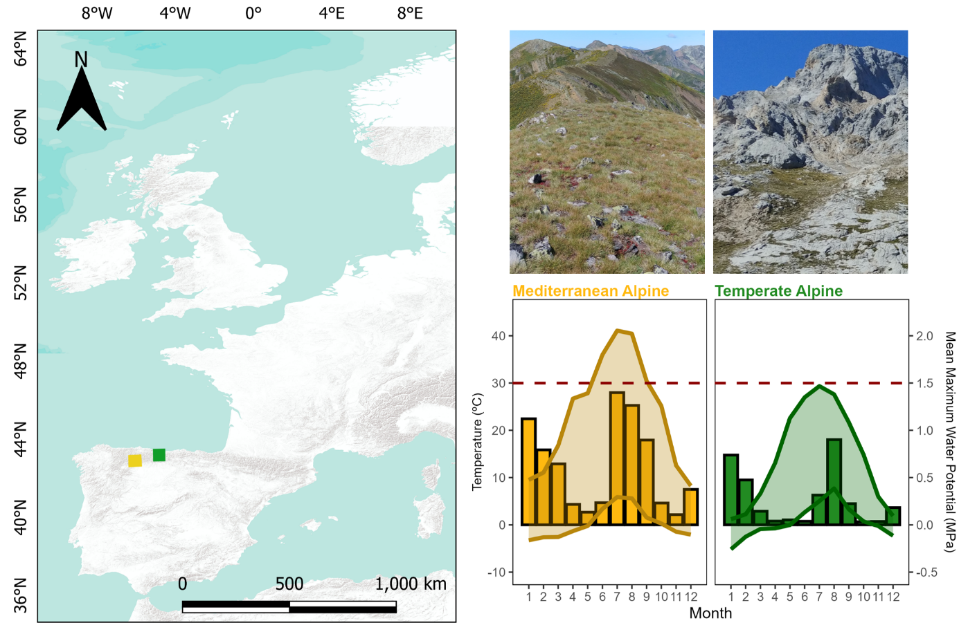
Figure 1 Description of the two alpine habitats investigated in the Cantabrian Mountains, northwestern Spain. Climatic diagram is based on Microlog SP3 data from 2021 to 2025 (MicroLog SP3, EMS Brno, Czech Republic; accuracy in temperature measurements: +/- 0.3 °C from -40 °C to 60 °C; water potential measurements with Delmhorst gypsum sensors measuring range from -0.1 to -15 bars), from the eight investigated sampling sites. Lines represent monthly maximum and minimum temperatures (left y-axis); bars represent the monthly averages of the Mean Maximum Water Potential in MPa (right y-axis). Dashed horizontal red line represents the permanent wilting point (-1.5 MPa).
Table 1. Ecological characteristics of the two habitats investigated in the Cantabrian Mountains, northwestern Spain. Growing season represents the period with daily mean temperatures above 5ºC (at 5 cm deep, Körner, 2021). Snow cover was calculated as the number of days in which the maximum temperatures were < 0.5 ºC and the minimum temperature was > -0.5 ºC, (Zhang et al. 2005). Soil data were collected at 5 cm deep in dominant plant communities representing both temperate (data period from to 2016 to 2024) and Mediterranean (2021 to 2024) alpine habitats.
 | Mediterranean Alpine Habitat | Temperate Alpine Habitat
Location | Valles de Omaña y Luna Biosphere Reserve | Picos de Europa National Park
Ph range (based on 40 samples) | 3.8 - 4.8 | 6.5 - 6.8
Growing season period | mid-April to early November | mid-May to early October
Daily mean water limitation during the growing season | -0.32 to -0.52 MPa | -0.15 to -0.45 MPa
Average soil temperature | 12.2ºC | 11.4 ºC
Annual snow cover | 13 to 116 days | 57.2 to 211 days

2.2 Species selection and seed sampling
During the summers of 2021 and 2022, we periodically sampled the two study habitats to collect seeds during the release dispersal times. We collected ripe seeds or fruits (hereafter ‘seeds’ for simplicity) of all fruiting species directly from the mother plants, involving at least 20 to 50 randomly chosen individuals. Following standard protocols for sampling seeds of wild populations, the goal was to collect 400 seeds from each species to maximise intraspecific genetic diversity (ENSCONET 2009). Field permits were necessary for seed sampling in Picos de Europa National Park (granted expedition number: CO/09/203/2021). We gathered sufficient seeds from 34 species in the temperate alpine habitat and 24 species in the Mediterranean alpine habitat. Taxonomic nomenclature follows (Jiménez-Alfaro, et al., 2021). Only Thymus praecox was collected in both habitats, while the rest of the species were represented by one seed lot (N = 57). After cleaning, seed collections from 2021 were kept in room conditions (22 ºC and 35% RH) for less than three months, then moved to hermetic pots with silica gel, in a refrigerator at 5ºC and darkness, to maintain high seed viability, until the beginning of the experiment. Seed collection from 2022 was cleaned and kept in room conditions for less than three months until the beginning of the experiment in November 2022. Seed collection year was initially included as a random factor in the model, but results remained consistent when excluded, thus we decided not to include it in the final models.

2.3 Germination treatments
Each seed lot was sown in 16 Petri dishes (90 mm Ø) containing 25 seeds each (reduced to 20 seeds per Petri dish for two species: Avenella flexuosa and Helictochloa marginata), using 1% agar sealed with parafilm to maintain moisture. The goal was to measure germination responses both during cold stratification and afterwards to other germination cues in non-dormant seeds; thus, all seed lots (N=57 lots) were subjected to a 5-month-long cold stratification period mimicking under-snow-like conditions (0.5ºC and darkness, Milbau et al., 2009).
Once cold stratification ended, the number of seeds that had germinated was recorded (radicle > 2 mm was used as the definition of germination), except for the Petri dishes going to the darkness treatment, which were covered with two layers of aluminium foil and immediately transferred to the growing chamber. Then, non-germinated seeds were transferred to new 90 mm Ø Petri dishes with two layers of filter paper (Filtros Anoia S.A. paper for germination assays, Ref.518G085) and 6 ml of distilled water, to subject the seeds to the control and constant temperature treatments. Figure 2 shows a schematic flowchart representing the seeds and germination steps applied, and Table 2 shows treatment conditions and their ecological significance. Previous research (Espinosa del Alba, Fernández-Pascual, and Jiménez-Alfaro 2024) has shown that the study species responds to two optimal germination temperatures. Consequently, we divided the species into these temperature regimes, programmed in four different growing chambers: some species went to a colder regime (15 – 5ºC alternating and 10ºC constant) and the other species to a warmer regime (22/12ºC alternating and 17ºC constant) (specific details available in GitHub, 2025). Optimal germination temperatures were included in preliminary models and had no effect on germination responses, so we excluded that factor from the analysis.
For the water limitation treatment, instead of distilled water, we added 6 ml of Polyethene glycol (PEG 6000) to simulate a water potential of -0.6 MPa (Megapascals). PEG is an inert water-binding polymer that creates a negative osmotic pressure, making it more difficult for seeds to absorb water. We chose a negative osmotic potential of -0.6 MPa based on reported water-limitation “thresholds” from other alpine areas (Orsenigo et al. 2015; Tudela-Isanta et al. 2018; Espinosa del Alba et al. 2025) and slightly above the mean water osmotic potential values registered in the area during the growing season (own data). As PEG solutions depend on experimental temperatures, two solutions were prepared according to (Michel and Kaufmann 1973) and (Villela, Doni Filho, and Sequeira 1991) to reach desired osmotic potentials at the mean temperatures in the two temperature regimes. Germination treatments were programmed in three Aralab growing chambers (Aralab climatic chamber Fitoclima S600 PL, equipped with 4 LED modules 11w 350mA) configured using Fitolog 9000 software (version 9308, Aralab Pharmaceutical Stability software) and one KBW growing chamber (KBW 400, Binder, Tuttlingen, Germany, specifically for the warm constant temperatures). We scored germination weekly for 6 weeks, removing germinated seeds from the Petri dishes (radicle > 2 mm long). To calculate darkness germination, we subtracted the mean germination from the final germination during cold stratification (measured in 12 petri dishes of each specific species). At the end of the experiment, we cut non-germinated seeds under a binocular stereoscope to visually assess if they were empty, infected, or normal. We considered seeds with white and firm embryos viable and removed empty or infected seeds from germination calculations (Baskin and Baskin 2014). The final dataset (Appendix S2) consisted of the raw scoring data for 56 species (57 seed lots) representing 21 plant families. A total of 18,694 viable seeds were used in the experiment. For further analysis, we removed seven species with zero germination across all treatments, assuming that we could not break dormancy or that the seed quality during collection was not optimal.
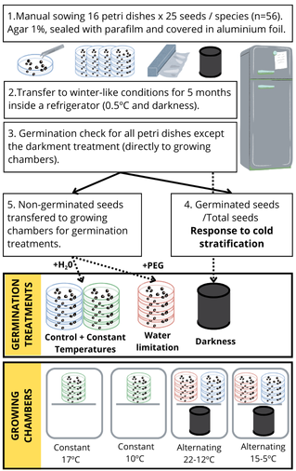
Figure 2 Schematic flowchart representing the seeds and germination steps applied in the study
Table 2. Description of germination experiments and their ecological significance
Treatment | Description | Ecological significance
Control | Alternating temperatures, 12 h photoperiod and water available. | Mimic environment with theoretical optimal conditions for alpine seed germination. Alternating temperatures, light and water available indicate safer germination microsites (Mondoni et al. 2012; Körner 2021).
Darkness | Alternating temperatures, constant darkness and water available. | Mimic the environment of seeds buried in the soil, without light, where some species can germinate (Doussi and Thanos 2002). Other species, especially those with small seeds, and low energy reserves, need light to germinate close to the soil surface (Bond, Honig, and Maze 1999).
Constant temperatures | Constant temperatures, 12 h light and water available. | Mimic the environment of seeds buried deeper in the soil, where there is narrow temperature variation, which might not stimulate germination as efficiently as alternating temperatures (Huarte and Benech-Arnold 2010).
Water limitation | Alternating temperatures, 12h light and PEG solution to simulate -0.6 MPa. | Mimic environment of seeds experiencing intermediate water limitation or drought conditions (Orsenigo et al., 2015).

2.4 Statistical analysis
All analyses and figures were done with R statistical software (Team and R Core Team 2024) and graphs using ggplot2 (Wickham 2016) and patchwork (Pedersen 2023).
We analysed the germination data by fitting Markov Chain Monte Carlo generalized linear mixed models (MCMCglmm) with Bayesian estimation and a multinomial2 family using the R package MCMCGLMM (Hadfield 2010). For all models, phylogeny was included as a random factor using a reconstructed tree for the 57 species created with the V.PHYLOMAKER R package (Jin and Qian 2019) using phylosignal and phylobase R packages (Keck et al. 2016). We used weakly informative priors, with parameter-expanded priors for the random effects. Each model was run for 1,000,000 iterations, with an initial burn of 100,000 and a thinning interval of 100. From the resulting posterior distributions, we calculated mean parameter estimates and 95% credible intervals (CI). To assess the significance of the models, we use the posterior mean from posterior probabilities and the credible intervals (CI). The posterior mean is an analogue of model effect sizes, and when the CI values do not overlap with 0, there is a significant effect of the explanatory variable.
For our first question, we analysed the germination responses to cold stratification (n=51 seed lots) to test if there were differences between temperate and Mediterranean alpine habitats (germination during cold stratification ~ Habitat). For our next questions, we excluded species with > 50% germination in cold stratification (n=10 seed lots) and also species with <10% germination in control conditions (n= 11 seed lots) to avoid still dormant or low-quality seed lots. We also applied a stricter threshold only considering species >50 % germination in control conditions; since findings remained consistent, we present these results only in Appendix S3. First, we tested the differences between control and water-limited germination (germination ~ treatment, n= 30 seed lots). Second, we measured the percentage of decreased germination in water limitation compared to control, e.g., if a specific species has germinated 80% in control and 20% in water limitation, the percentage germination decrease is equal to 75%:
$\left(1-\frac{20}{80}\right)*100=75$
Then, we tested the differences in the percentual germination decrease between alpine habitats with an Exponential MCMC-GLMM (germination reduction ~ habitats). To control germination responses to fine-scale germination drivers (n=30 seed lots), we preliminarily tested whether different optimal temperatures affected germination, but were not significant and were not included in further tests. We compared germination between treatments (light control vs dark and alternating vs constant temperatures) (germination ~ treatment); and, within each germination treatment, we tested germination differences between habitats (germination ~ habitat). Model assumptions were visually checked and fulfilled (we checked for patterns in the trace of the sampled output (time series) and density estimates of each explanatory variable (Hadfield 2017).

3. Results

3.1. Germination during cold stratification
During cold stratification, germination ranged from 0 (e.g., Armeria cantabrica) to 100% (e.g., Teesdalia conferta); with 10 species (out of 50) germinating >50%, three from the temperate alpine and seven from the Mediterranean alpine (Figure 3A). The top-10 species with the highest germination during cold stratification (named as “>50% germination” in Figure 3A) were removed from further analysis; the rest of the species were kept, assuming they would mostly germinate during spring and would therefore be exposed to the germination cues after cold stratification. There was an average of 0.24 (+/- 0.01) germination proportion in species from the Mediterranean alpine habitat, while less than 0.08 (+/- 0.006) of seeds germinated in the temperate alpine habitat. Habitat comparison detected significant differences (post. mean = -3.56, CI = [-6.22|-0.9]), with higher germination in the Mediterranean (Figure 3B). The response of cold stratification across habitats was significantly modulated by phylogeny (post. mean = 0.95, CI: [0.88|1) (see model details in Appendix S3).
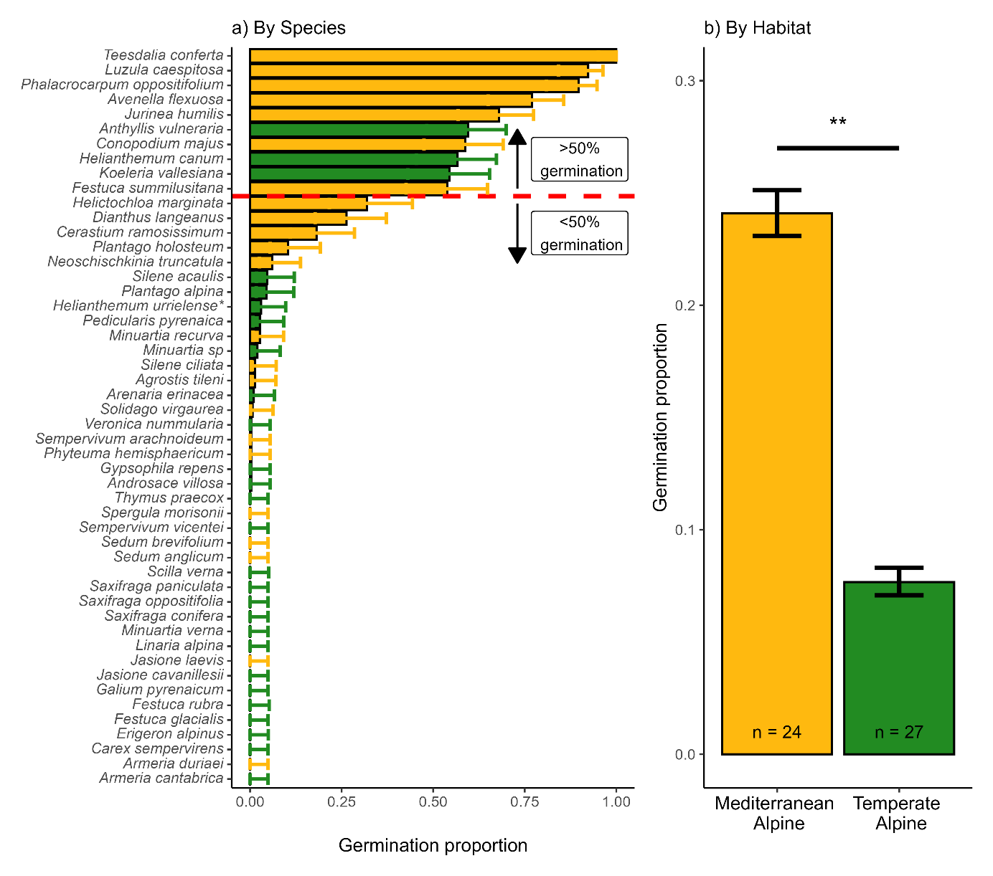
Figure 3 Germination during cold stratification (0.5 ºC and darkness) in 50 species from contrasting Mediterranean and Temperate alpine habitats in the Cantabrian Mountains, northwestern Spain. A) Accumulated germination during cold stratification across species (n = 50) coloured by habitat. The red line marks the limit of species with >50% germination during cold stratification that were removed from further analysis. B) Differences across habitats. Bars represent the mean germination proportion during cold stratification, and the error bar represents the binomial confidence intervals; significance derives from multinomial MCMCGLMM models, ** = p-value<0.01. Helianthemum urrielense* = Helianthemum apenninum subsp. Urrielense. n = number of species in each habitat.

3.2. Germination under water limitation
Water limitation exhibited a significantly negative effect on overall germination proportion, from 0.56 (+/- 0.02) in the control to 0.19 (+/- 0.02) under water limitation (post. mean = -3.31, CI= [-3.69|-2.91]) (Figure 4A). Although the mean percentual decrease was slightly higher in the temperate alpine habitat (mean germination reduction of 80.6% and 62.6% temperate alpine and Mediterranean, respectively), the differences were not significant (post. mean = -35.5, CI= [-144.3|81.36]) (Figure 4B). The percentage of decreased germination ranged from 100%, i.e., no germination at all under water limitation (e.g., Sedum brevifolium) to 1%, i.e., practically no effect of water limitation (-0.6 MPa) (e.g., Plantago holosteum); see Figure 4C for species individual responses in both control and water limitation treatments. The germination response to water limitation does not appear to be modulated by phylogeny (see model details in Appendix S3).
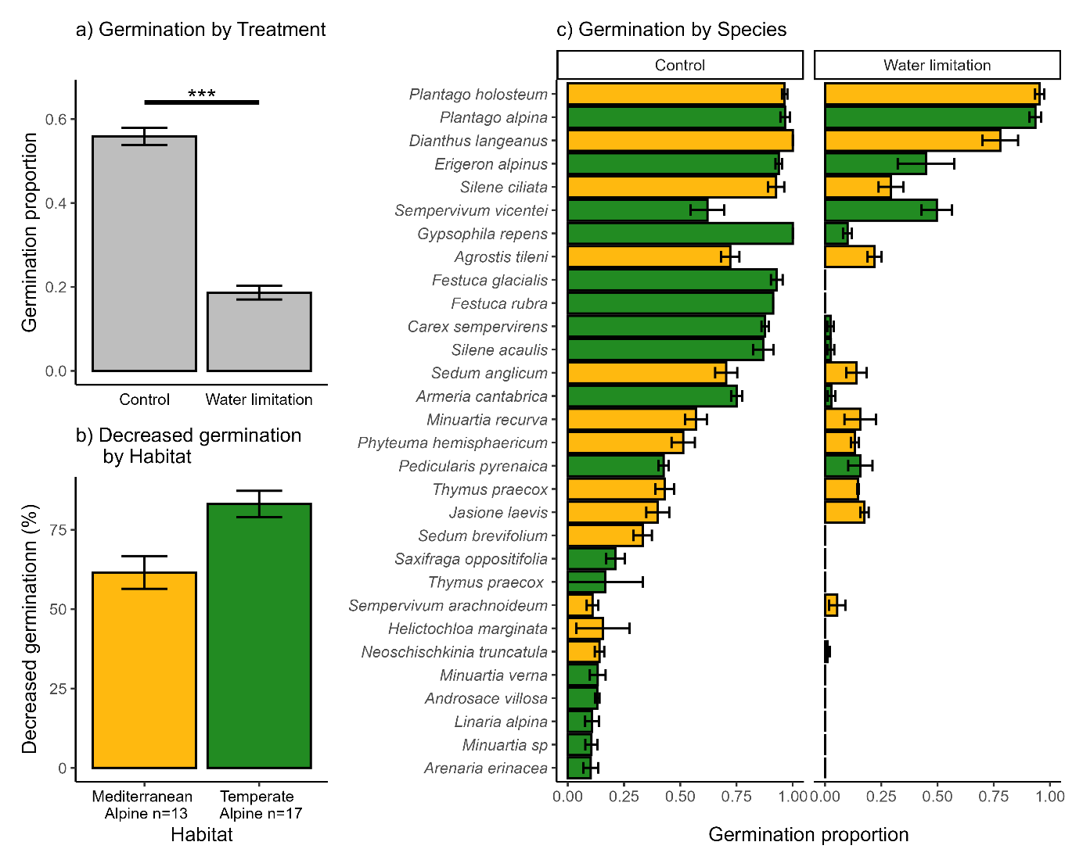
Figure 4 Germination responses under water limitation in 30 species from Mediterranean and Temperate alpine habitats in the Cantabrian Mountains, northwestern Spain. A) Bars represent the mean germination observed per treatment, and error bars represent binomial confidence intervals. Significances from multinomial MCMC-GLMM models *** = p-value<0.001. B) Bars represent the mean germination reduction under water limitation in each habitat, and error bars represent the Standard error of the mean. C) Germination of each species for both control and water limitation treatments, bars represent the mean germination and error bars represent the Standard error of the mean. Colour represents the species' habitat.

3.3. Germination responses to dark and constant temperatures
The highest mean germination proportion was recorded in the constant temperature treatment (0.6 +/- 0.02), followed by control (0.56 +/- 0.01) and darkness (0.45 +/- 0.02). Germination was significantly lower in darkness (post. mean = -0.58, CI= [-0.9|-0.27]) compared to the control; with no significant differences between constant temperatures and control (post. mean = 0.18, CI= [-0.18|0.49]) (Figure 5A). When comparing both habitats, we did not observe significant differences in germination within either treatment, although the Mediterranean habitat showed slightly higher germination in control and constant temperature treatments (Figure 5B, model details in Appendix S3). Individual species germination responses to each treatment are available in Appendix S1 and Appendix S4.
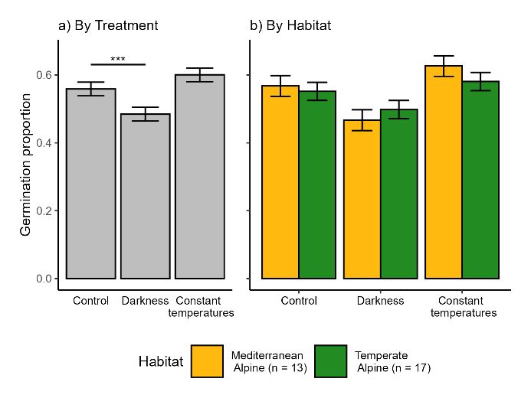
Figure 5 Germination responses to darkness and constant temperature treatments in 30 species from Mediterranean and temperate alpine habitats of the Cantabrian Mountains, northwestern Spain. A) Bars represent the mean germination observed per treatment, error bars represent binomial confidence intervals, significances from multinomial MCMC-GLMM models, *** = p-value < 0.005. B) Bars represent the mean germination observed per treatment in each Habitat, and error bars represent binomial confidence intervals; n = number of species in each alpine habitat included in this analysis

4. Discussion
In this study, we focused on germination cues related to snow cover and water availability in two contrasting alpine habitats with different macroclimates, while controlling for other known germination cues (responses to darkness and constant temperatures). The main germination differences between habitats were related to their response to cold stratification. Nevertheless, both habitats showed similar responses to water limitation and darkness (by decreasing germination).
As expected, we found higher germination during cold stratification in species from a Mediterranean alpine habitat. Due to experimental constraints, we cannot rule out that the germination recorded is not directly related to cold stratification itself but to the relief of dormancy during the 3 months of dry storage. The latter would be translated into “autumn germination” in field conditions rather than “under snow”. To address this limitation, we compared these results with previously published germination phenology for the same species (Espinosa del Alba, Fernández-Pascual, and Jiménez-Alfaro 2024). In that study, half of our ten species with >50% germination in cold stratification germinated during the “autumn” period, and only three of them (Luzula caespitosa, Jurinea humilis and Conopodium majus) germinated better during the winter/spring period after a cold-wet stratification period. This supports the presence of lower physiological dormancy within the Mediterranean alpine species pool (Giménez-Benavides, Escudero, and Pérez-García 2005), and is consistent with the Mediterranean germination syndrome, characterised by a preference for germination in darkness and at lower temperatures (Doussi and Thanos 2002; Carta et al. 2017). In either case, these germination responses enable seeds to capitalise on early-season water availability and develop before the onset of summer drought, either germinating in autumn, under the snow or in early spring when temperatures are still low. Interestingly, the three species from the temperate habitat with >50% germination during stratification (Anthyllis vulneraria, Helianthemum canum and Koeleria vallesiana) are adapted to the driest and least snowy places in the study area (Jiménez-Alfaro et al. 2014), indicating a preference for Mediterranean-like conditions.
The only previous study comparing cold stratification (0 °C and darkness at 0, 3, and 5 months) between alpine habitats found higher germination during cold stratification in species from the calcareous habitat (drier) compared to those from the siliceous habitat (wetter) (Tudela-Isanta et al. 2017). This suggests a pattern where alpine species adapted to drier conditions germinate better under cold and humid conditions. Although we interpret that these species can germinate either in autumn or “under snow”, the snow cover period is highly variable and relatively short in our Mediterranean habitat (i.e., mild winter), so the study species might not need specific adaptations to avoid snow, especially if the seedlings are able to survive through winter. In contrast, our temperate habitat has a longer snow-cover period, so the species might require strategies to avoid it (e.g., deep dormancy and warm germination), in line with the common alpine germination patterns. Notably, among the top ten species with higher cold stratification germination, eight are generalist species that extend their distribution to subalpine grasslands. Subalpine species are known to germinate more effectively under snow (Fernández-Pascual et al. 2017) or at colder temperatures (Baskin and Baskin 2014); therefore, our results align with those previously reported. Interestingly, some of our studied species (Luzula caespitosa (Juncaceae), Teesdalia conferta (Brassicaceae) or Conopodium majus (Apiaceae)) seem to be restricted to germinating only under snow or at low temperatures, corroborating previous research (Fernández-Pascual et al. 2017; Espinosa del Alba, Fernández-Pascual, and Jiménez-Alfaro 2024), either due to dormancy restrictions or underdeveloped embryos (Blandino et al. 2018). Another point worth mentioning is that the observed germination differences could also be related to seed dispersal timing. Seed dispersal in our temperate habitat, which is colder and wetter, usually occurs in September, when temperatures are lower and decline rapidly. In contrast, in our Mediterranean habitat, seed dispersal occurs in mid-August, with temperatures still high but with drier conditions, thus these differences could potentially have an impact in subsequent germination phenology.
Corroborating previous studies from alpine habitats (Orsenigo et al. 2015; Gya et al. 2023; Espinosa del Alba et al. 2025), water limitation negatively affected germination in most study species, regardless of the habitat type. Low moisture availability leads to partial or complete inhibition of physiological processes, which can hinder seeds from germinating (Baskin and Baskin 2014). Against our initial expectation, we found no significant differences between germination reduction due to water limitation across our two alpine habitats. Nevertheless, it is interesting to note that species from the Mediterranean habitat seem to exhibit intermediate germination responses to water limitation (mostly between 25% and 75% decreases). In comparison, most species from our temperate habitat showed a germination reduction higher than 90%. These results suggest that alpine regeneration from the temperate habitat are likely to face higher detrimental effects in future drier conditions, since many of the current occurring species will reduce their germinability. Additionally, more strict alpine species, such as Silene acaulis, Festuca glacialis, or Carex sempervirens, generally showed higher decreased germination under water limitation than other subalpine or generalist species (e.g., Plantago holosteum). When these species migrate from lower-elevation habitats, they usually occur in sites with early snowmelt and are subjected to higher summer drought. In the Mediterranean habitat, in comparison, the higher temperature and lower soil moisture conditions during the growing season could potentially be selecting for species with higher drought-tolerant germination (Espinosa del Alba et al, 2025); nevertheless, more studies are needed to corroborate that idea. Our findings further indicate that, besides general patterns observed within the study habitats, the response of different species within the local species pool may vary according to individual species' niches. Nevertheless, laboratory PEG results must be taken with caution (Camacho et al., 2021). PEG solutions can affect oxygen availability (Mexal et al., 1975), potentially confounding our water-limited treatments, although other studies concluded that PEG solution-seed contact did not reduce germination (Emmerich and Hardegree, 1990). It is important to point out that, in our experiments, the solution did not cover seeds; they were only in contact through the imbibed germination paper. We assumed that, even if this aspect of PEG solutions has an effect, it would be similar across the study species, thereby allowing us to compare species/habitat responses. In the field, soil water potential is influenced by dynamic soil hydraulic conductivity, which, in turn, depends on soil textural properties (Camacho et al., 2021); thus, for a more reliable conclusion, it would be important to confirm our results with field experimentation.
The significantly lower germination we observed in darkness conditions is in concordance with the general alpine germination patterns (Shimono and Kudo 2005; Mondoni et al. 2009; Fernández-Pascual et al. 2021) and Mediterranean mountain specialist germination (Giménez-Benavides, Escudero, and Pérez-García 2005; Picciau et al. 2019; Cruz-Tejada et al. 2024). Surprisingly, both systems exhibited no germination differences between alternating (control treatment) and constant temperatures, in line with the results presented by Liu et al., (2013) but opposite to the meta-analysis by Fernández-Pascual et al. (2021). Light/dark and alternate/constant temperatures can be interpreted as germination cues for detecting safe microsites (Jumpponen et al., 1999), either vegetation gaps, crevices or soil depth. Dark and constant temperatures can be interpreted as increased burial depth, which may be detrimental for small seeds, which have lower energy stored and might be unable to survive the first few centimetres of soil until reaching the surface (Saatkamp et al. 2011), potentially the case for most species in our study. Surprisingly, beyond the negative influence of darkness we found equal germination between alternating and constant temperature regimes. Literature reports indicate that diurnally alternating temperatures can promote radicle growth by reducing the ratio of abscisic acid to gibberellin (Huarte and Benech-Arnold 2010), thereby relieving dormancy and stimulating germination (Fenner and Thompson 2005; Fernández-Pascual, Seal, and Pritchard 2015). One potential explanation is that the alternating regime in our experimental setting did not have sufficient thermal amplitude to promote a differential germination. According to Liu et al. (2013), an alternative explanation would be that alpine areas experience a notable temperature fluctuation all year long, thus fluctuating temperatures might not be a reliable germination cue to indicate appropriate timing. Consequently, other cues like water availability or maximum daily temperatures might have a stronger signal than fluctuating temperatures. This aspect of germination requires further exploration in alpine areas to draw reliable conclusions.
Overall, the results presented in this study suggest that alpine germination of many species will be heavily impacted by changes in water availability derived from reduced snow cover, diminishing cold stratification, and increasing water limitation under current climate warming (Morán-Tejeda et al. 2013). The responses we observed indirectly favour less dormant species (Verdú et al. 2005; Mondoni et al. 2015) or species with no stratification requirement (Sommerville, Martyn, and Offord 2013). Some germination responses will be partly alleviated by the plasticity of physiological seed dormancy in response to the seed maturation temperature (Fernández-Pascual et al. 2013; Carta et al. 2015; Fernández-Pascual, Mattana, and Pritchard 2019) or via maternal effects that facilitate acclimatisation to changing environments. Nevertheless, due to large species-specific variation in germination requirements (Orsenigo et al. 2015; Walder and Erschbamer 2015; Fernández-Pascual et al. 2017), future alpine communities might shift towards a more drought-resistant community. Accordingly, habitat variations in snow cover can alter plant community structure by influencing seed germination patterns (Anniwaer et al. 2020) and may also have a more substantial impact on seed germination than climate warming (Drescher 2014). Expanding our knowledge about the specific effects of shortened snow cover protection (Briceño, Hoyle, and Nicotra 2015; Anniwaer et al. 2020) and increased water limitation on alpine germination is needed to forecast future potential impacts of climate change, eg., experiencing reduced snow (Morán-Tejeda et al. 2013) or increased drought (Beniston et al. 2007).
Conclusion
This study demonstrates that species from Mediterranean alpine habitats diverge from typical alpine germination patterns primarily in their responses to cold and wet winter conditions. Our results open the door to other germination strategies linked to multiple climatic variations occurring in alpine habitats worldwide (Testolin, Attorre, and Jiménez-Alfaro 2020). Species-specific germination responses suggest that, in a warmer and drier alpine scenario, winner species will be those with lower requirements for cold stratification and water availability for germination, potentially facilitating a directional shift in alpine community composition. Our results also support the idea that seed germination traits, especially the responses to snow and water availability, might play an essential role in understanding the regeneration ecology of plant communities under climate change in different alpine systems (Briceño, Hoyle, and Nicotra 2015; Mondoni et al. 2022). Nevertheless, these results are based on laboratory experiments, and how the findings might transfer to natural communities remain untested. Therefore, increasing field experimentation in seed regeneration (Milbau et al. 2009) is still needed to predict climate-driven responses of alpine plant communities more precisely.

5. References
Anniwaer, A., Y. Su, X. Zhou, and Y. Zhang. 2020. “Impacts of Snow on Seed Germination Are Independent of Seed Traits and Plant Ecological Characteristics in a Temperate Desert of Central Asia.” Journal of Arid Land 12 (5): 775–90. https://doi.org/10.1007/s40333-020-0059-9.
Baskin, C. C., and J. M. Baskin. 2014. Seeds. Ecology, Biogeography and Evolution of Dormancy and Germination. Seeds. 2nd Editio. San Diego, CA, USA: Academic Press. https://doi.org/10.1016/B978-0-12-416677-6.00001-9.
Beniston, M., D. B. Stephenson, O. B. Christensen, C. A.T. Ferro, C. Frei, S. Goyette, K. Halsnaes, et al. 2007. “Future Extreme Events in European Climate: An Exploration of Regional Climate Model Projections.” Climatic Change 81: 71–95. https://doi.org/10.1007/s10584-006-9226-z.
Blandino, C., E. Fernández-Pascual, M. Marin, A. Vernet, and H. W. Pritchard. 2018. “Seed Ecology of the Geophyte Conopodium Majus (Apiaceae), Indicator Species of Ancient Woodland Understories and Oligotrophic Meadows.” Plant Biology 21 (3): 487–97. https://doi.org/10.1111/plb.12872.
Bond, W. J., M. Honig, and K. E. Maze. 1999. “Seed Size and Seedling Emergence: An Allometric Relationship and Some Ecological Implications.” Oecologia 120 (1): 132–36. https://doi.org/10.1007/s004420050841.
Briceño, V. F., G. L. Hoyle, and A. B. Nicotra. 2015. “Seeds at Risk: How Will a Changing Alpine Climate Affect Regeneration from Seeds in Alpine Areas?” Alpine Botany 125 (2): 59–68. https://doi.org/10.1007/s00035-015-0155-1.
Camacho E. M., J. L. Heitman, T. W. Gannon, A. Amoozegar and R.G. Leon. 2021. "Seed germination responses to soil hydraulic conductivity and polyethylene glycol (PEG) osmotic solutions." Plant Soil 462:175-188. https://doi.org/10.1007/s11104-021-04857-5.
Carta, A., R. Probert, G. Puglia, L. Peruzzi, and G. Bedini. 2015. “Local Climate Explains Degree of Seed Dormancy in Hypericum Elodes L. (Hypericaceae).” Plant Biology 18 (Suppl. 1): 76–82. https://doi.org/10.1111/plb.12310.
Carta, A., E. Skourti, E. Mattana, F. Vandelook, and C. A. Thanos. 2017. “Photoinhibition of Seed Germination : Occurrence , Ecology and Phylogeny Photoinhibition of Seed Germination : Occurrence , Ecology and Phylogeny.” Seed Science Research 27: 131–53. https://doi.org/10.1017/S0960258517000137.
Cavieres, L. A., and M. T. K. Arroyo. 2000. “Seed Germination Response to Cold Stratification Period and Thermal Regime in Phacelia Secunda (Hydrophyllaceae): Altitudinal Variation in the Mediterranean Andes of Central Chile.” Plant Ecology 149 (1): 1–8. https://doi.org/10.1023/A:1009802806674.
Cavieres, L. A., and A. Sierra-Almeida. 2018. “Assessing the Importance of Cold-Stratification for Seed Germination in Alpine Plant Species of the High-Andes of Central Chile.” Perspectives in Plant Ecology, Evolution and Systematics 30: 125–31. https://doi.org/10.1016/j.ppees.2017.09.005.
Cruz-Tejada, D. M., E. Mattana, S. Rosbakh, E. Fernández-Pascual, and A. Carta. 2024. “Macroclimatic Convergence and Habitat Specialisation Shape the Mediterranean Seed Germination Syndrome.” Ecology and Evolution 14 (11): 1–8. https://doi.org/10.1002/ece3.70527.
Decker, K.L.M., D. Wang, C. Waite, and T. Scherbatskoy. 2003. “Snow Removal and Ambient Air Temperature Effects of Forest Soil Temperatures in Northern Vermont.” Soil Science Society of America Journal 67 (5): 1629–1629. https://doi.org/10.2136/sssaj2003.1629.
Donohue, K., R. Rubio De Casas, L. Burghardt, K. Kovach, and C. G. Willis. 2010. “Germination, Postgermination Adaptation, and Species Ecological Ranges.” Annual Review of Ecology, Evolution, and Systematics 41: 293–319. https://doi.org/10.1146/annurev-ecolsys-102209-144715.
Doussi, M. A., and C. A. Thanos. 2002. “Ecophysiology of Seed Germination in Mediterranean Geophytes. 1. Muscari Spp.” Seed Science Research 12 (3): 193–201. https://doi.org/10.1079/ssr2002111.
Drescher, M. 2014. “Snow Cover Manipulations and Passive Warming Affect Post-Winter Seed Germination: A Case Study of Three Cold-Temperate Tree Species.” Climate Research 60 (3): 175–86. https://doi.org/10.3354/cr01237.
Emmerich, W. E. and S. P. Hardegree. 1990. "Polyethylene Glycol Solution contact effects on seed germination." Agronomy Journal 82: 1103-1107. https://doi.org/10.2134/agronj1990.00021962008200060015x
ENSCONET. 2009. ENSCONET Seed Collecting Manual for Wild Species. Edited by Kew (UK) Royal Botanic Gardens and Universidad Politécnica de Madrid (Spain).
Espinosa del Alba, C., E. Fernández-Pascual, and B. Jiménez-Alfaro. 2024. “Microclimatic Variation Regulates Seed Germination Phenology in Alpine Plant Communities.” Journal of Ecology, no. November: 1–14. https://doi.org/10.1111/1365-2745.14461.
Espinosa del Alba, C., D. M.Cruz-Tejada, B. Jiménez-Alfaro, and E. Fernández-Pascual. 2025. “Functional Intraspecific Variation in the Base Water Potential for Seed Germination along Soil Microclimatic Gradients.” Functional Ecology 39 (3): 897–911. https://doi.org/10.1111/1365-2435.14754.
Fenner, M., and K. Thompson. 2005. “The Ecology of Seeds.” In The Ecology of Seeds, edited by M. Fenner and K. Thompson, 110–35. Cambridge, UK: Cambridge: Cambridge Uniersity Press.
Fernández-Pascual, E., B. Jiménez-Alfaro, and A. Bueno. 2017. “Comparative Seed Germination Traits in Alpine and Subalpine Grasslands: Higher Elevations Are Associated with Warmer Germination Temperatures.” Plant Biology 19 (1): 32–40. https://doi.org/10.1111/plb.12472.
Fernández-Pascual, E., A. Carta, A. Mondoni, L. A. Cavieres, S.Rosbakh, S.Venn, A. Satyanti, et al. 2021. “The Seed Germination Spectrum of Alpine Plants: A Global Meta-Analysis.” New Phytologist 229 (6): 3573–86. https://doi.org/10.1111/nph.17086.
Fernández-Pascual, E., B. Jiménez-Alfaro, J. Caujapé-Castells, R. Jaén-Molina, and T. E. Díaz. 2013. “A Local Dormancy Cline Is Related to the Seed Maturation Environment, Population Genetic Composition and Climate.” Annals of Botany 112 (5): 937–45. https://doi.org/10.1093/aob/mct154.
Fernández-Pascual, E., E. Mattana, and H. W. Pritchard. 2019. “Seeds of Future Past: Climate Change and the Thermal Memory of Plant Reproductive Traits.” Biological Reviews 94 (2): 439–56. https://doi.org/10.1111/brv.12461.
Fernández-Pascual, E., C. E. Seal, and H. W. Pritchard. 2015. “Simulating the Germination Response to Diurnally Alternating Temperatures under Climate Change Scenarios: Comparative Studies on Carex Diandra Seeds.” Annals of Botany 115 (2): 201–9. https://doi.org/10.1093/aob/mcu234.
García-Gutiérrez, T., B. Jiménez-Alfaro, E. Fernández-Pascual, and J. V. Müller. 2018. “Functional Diversity and Ecological Requirements of Alpine Vegetation Types in a Biogeographical Transition Zone.” Phytocoenologia 48 (1): 77–89. https://doi.org/10.1127/phyto/2017/0224.
Giménez-Benavides, L., A. Escudero, and F. Pérez-García. 2005. “Seed Germination of High Mountain Mediterranean Species: Altitudinal, Interpopulation and Interannual Variability.” Ecological Research 20 (4): 433–44. https://doi.org/10.1007/s11284-005-0059-4.
Gya, R., S. R.Geange, J. S. Lynn, J. P. Töpper, Ø. Wallevik, C. Zernichow, and V. Vandvik. 2023. “A Test of Local Adaptation to Drought in Germination and Seedling Traits in Populations of Two Alpine Forbs across a 2000 Mm/Year Precipitation Gradient.” Ecology and Evolution 13 (2): 1–19. https://doi.org/10.1002/ece3.9772.
Hadfield, J. D. 2017. MCMCglmm Course Notes.
Hadfield, J. D. 2010. “MCMCglmm: MCMC Methods for Multi-Response GLMMs in R.” Journal of Statistical Software 33 (2): 1–22. http://www.jstatsoft.org/.
Huarte, H. R., and R. L. Benech-Arnold. 2010. “Hormonal Nature of Seed Responses to Fluctuating Temperatures in Cynara Cardunculus (L.).” Seed Science Research 20 (1): 39–45. https://doi.org/10.1017/S0960258509990249.
Jiménez-Alfaro, B., S. Abdulhak, F. Attorre, A. Bergamini, M. L. Carranza, A. Chiarucci, and M. Winkler. 2021. “Post-Glacial Determinants of Regional Species Pools in Alpine Grasslands.” Global Ecology Biogeography 30: 1101–15. https://doi.org/https://doi.org/10.1111/geb.13274.
Jiménez-Alfaro, B., J. I. Alonso Felpete, Á. Bueno Sánchez, and J. A. Fernández Prieto. 2014. “Alpine Plant Communities in the Picos de Europa Calcareous Massif (Northern Spain).” Lazaroa 35 (0). https://doi.org/10.5209/rev_laza.2013.v34.n1.43646.
Jiménez-Alfaro, B., L. Carlón, E. Fernández-Pascual, C. Acedo, E. Alfaro-Saiz, R. Alonso Redondo, E. Cires, et al. 2021. “Checklist of the Vascular Plants of the Cantabrian Mountains.” Mediterranean Botany 42: 1–60. https://doi.org/10.5209/MBOT.74570.
Jin, Y., and H. Qian. 2019. “V.PhyloMaker: An R Package That Can Generate Very Large Phylogenies for Vascular Plants.” Ecography 42 (8): 1353–59. https://doi.org/10.1111/ecog.04434.
Jumpponen, A., H. Väre, K.G.Mattson, R. Ohtonen and J.M.Trappe. 1999. "Characterization of 'safe sites' for pioneers in primary succession on recently deglaciated terrain. Journal of Ecology, 87: 98-105.https://doi.org/10.1046/j.1365-2745.1999.00328.x
Keck, F., F. Rimet, A. Bouchez, and A. Franc. 2016. “Phylosignal: An R Package to Measure, Test, and Explore the Phylogenetic Signal.” Ecology and Evolution 6 (9): 2774–80. https://doi.org/10.1002/ece3.2051.
Körner, C.. 2021. Alpine Plant Life. Edited by Springer Nature Switzerland AG 2021. 3rd ed. Springer Cham. https://doi.org/10.1007/978-3-030-59538-8.
Liu, K., J. M. Baskin, C.C. Baskin, H. Bu, G.Du and M. Ma. 2013. "Effect of diurnal fluctuating versus constant temperatures on germination of 445 species from the Eastern Tibet Plateu." Plos One 8 (7) 10.1371/journal.pone.0069364
Margreiter, V., K. Pagitz, C. Berg, P. Schwager, and B.Erschbamer. 2020. “Pros and Cons of Using a Standard Protocol to Test Germination of Alpine Species.” Plant Ecology 221 (11): 1045–67. https://doi.org/10.1007/s11258-020-01061-w.
Mexal J., J.T. Fisher, J.Osteryoung and C.P. P. Reid. 1975. "Oxygen availability in Polyethylene Glycol Solutions and its implications in plant-water relations." Plant Physiology 55: 20-24. https://doi.org/10.1104/pp.55.1.20
Michel, B. E., and M. R. Kaufmann. 1973. “The Osmotic Potential of Polyethylene Glycol 60001,” 914–16.
Milbau, A., B. J. Graae, A. Shevtsova, and I. Nijs. 2009. “Effects of a Warmer Climate on Seed Germination in the Subarctic.” Annals of Botany 104 (2): 287–96. https://doi.org/10.1093/aob/mcp117.
Mondoni, A., M. I. Daws, J. Belotti, and G. Rossi. 2009. “Germination Requirements of the Alpine Endemic Silene Elisabethae Jan: Effects of Cold Stratification, Light and GA3.” Seed Science and Technology 37 (1): 79–87. https://doi.org/10.15258/sst.2009.37.1.10.
Mondoni, A., B. Jiménez-Alfaro, and L. A. Cavieres. 2022. “Effect of Climate Change on Plant Regeneration from Seeds in the Arctic and Alpine Biome.” In Plant Regeneration from Seeds: A Global Warming Perspective, edited by Carol C. Baskin and Jerry M. Baskin, 1st ed., 3–18. London, UK: Academic Press.
Mondoni, A., S. Pedrini, G.Bernareggi, G. Rossi, T. Abeli, R. J. Probert, M. Ghitti, C. Bonomi, and S. Orsenigo. 2015. “Climate Warming Could Increase Recruitment Success in Glacier Foreland Plants.” Annals of Botany 116 (6): 907–16. https://doi.org/10.1093/aob/mcv101.
Mondoni, A., G. Rossi, S. Orsenigo, and R. J. Probert. 2012. “Climate Warming Could Shift the Timing of Seed Germination in Alpine Plants.” Annals of Botany 110 (1): 155–64. https://doi.org/10.1093/aob/mcs097.
Morán-Tejeda, E., S. Herrera, J. I. López-Moreno, J. Revuelto, A. Lehmann, and M. Beniston. 2013. “Evolution and Frequency (1970-2007) of Combined Temperature-Precipitation Modes in the Spanish Mountains and Sensitivity of Snow Cover.” Regional Environmental Change 13 (4): 873–85. https://doi.org/10.1007/s10113-012-0380-8.
Nogués Bravo, D., M. B. Araújo, T. Lasanta, and J. I. López-Moreno. 2008. “Climate Change in Mediterranean Mountains during the 21st Century.” Ambio 37 (4): 280–85. https://www.jstor.org/stable/25547898.
Notarnicola, R. F., A. B. Nicotra, L. E. B. Kruuk, and P. A. Arnold. 2022. “Effects of Warming Temperatures on Germination Responses and Trade-Offs between Seed Traits in an Alpine Plant.” Journal of Ecology 111 (1): 62–76. https://doi.org/10.1111/1365-2745.14014.
Orsenigo, S., T.Abeli, G. Rossi, P. Bonasoni, C. Pasquaretta, M. Gandini, and A. Mondoni. 2015. “Effects of Autumn and Spring Heat Waves on Seed Germination of High Mountain Plants.” PLoS ONE 10 (7): 1–17. https://doi.org/10.1371/journal.pone.0133626.
Pedersen, T. L. 2023. “Patchwork: The Composer of Plots.” https://cran.r-project.org/package=patchwork.
Picciau, R., H. W. Pritchard, E. Mattana, and G. Bacchetta. 2019. “Thermal Thresholds for Seed Germination in Mediterranean Species Are Higher in Mountain Compared with Lowland Areas.” Seed Science Research 29 (1): 44–54. https://doi.org/10.1017/S0960258518000399.
Rosbakh, S., E. Fernández-Pascual, A. Mondoni, and V. Onipchenko. 2022. "Alpine plants communities differ in their seed germination requirements along a snowmelt gradient in the Caucasus." Alpine Botany 132: 223-232. https://doi.org/10.1007/s00035-022-00286-x
Saatkamp, A., L. Affre, T. Dutoit, and P. Poschlod. 2011. “Germination Traits Explain Soil Seed Persistence across Species: The Case of Mediterranean Annual Plants in Cereal Fields.” Annals of Botany 107 (3): 415–26. https://doi.org/10.1093/aob/mcq255.
Schwienbacher, E., J. A.Navarro-Cano, G. Neuner, and B. Erschbamer. 2011. “Seed Dormancy in Alpine Species.” Flora: Morphology, Distribution, Functional Ecology of Plants 206 (10): 845–56. https://doi.org/10.1016/j.flora.2011.05.001.
Shimono, Y., and G. Kudo. 2005. “Comparisons of Germination Traits of Alpine Plants between Fellfield and Snowbed Habitats.” Ecological Research 20 (2): 189–97. https://doi.org/10.1007/s11284-004-0031-8.
Sillmann, J., V. V. Kharin, F. W. Zwiers, X. Zhang, and D. Bronaugh. 2013. “Climate Extremes Indices in the CMIP5 Multimodel Ensemble: Part 2. Future Climate Projections.” Journal of Geophysical Research Atmospheres 118 (6): 2473–93. https://doi.org/10.1002/jgrd.50188.
Sommerville, K. D., A. J. Martyn, and C. A. Offord. 2013. “Can Seed Characteristics or Species Distribution Be Used to Predict the Stratification Requirements of Herbs in the Australian Alps?” Botanical Journal of the Linnean Society 172 (2): 187–204. https://doi.org/10.1111/boj.12021.
Team, R Core, and R Core Team. 2024. “R: A Language and Environment for Statistical Computing.” Vienna: R Foundation for Statistical computing. https://www.r-project.org/.
Testolin, R., F. Attorre, and B. Jiménez-Alfaro. 2020. “Global Distribution and Bioclimatic Characterization of Alpine Biomes.” Ecography 43 (6): 779–88. https://doi.org/10.1111/ecog.05012.
Tudela-Isanta, M., E. Fernández-Pascual, M. Wijayasinghe, S. Orsenigo, G. Rossi, H. W. Pritchard, and A. Mondoni. 2017. “Habitat-Related Seed Germination Traits in Alpine Habitats.” Ecology and Evolution 8 (1): 150–61. https://doi.org/10.1002/ece3.3539.
Tudela-Isanta, M., E. Ladouceur, M. Wijayasinghe, H. W. Pritchard, and A. Mondoni. 2018. “The Seed Germination Niche Limits the Distribution of Some Plant Species in Calcareous or Siliceous Alpine Bedrocks.” Alpine Botany 128 (1): 83–95. https://doi.org/10.1007/s00035-018-0199-0.
Vázquez-Ramirez, J., and S. E. Venn. 2021. “Seeds and Seedlings in a Changing World : A Systematic Review and Meta-Analysis from High Altitude and High Latitude Ecosystems.” Plants 10 (768). https://doi.org/10.3390/plants10040768.
Verdú, M., and A. Traveset. 2005. “Early emergence enhances plant fitness: a phylogenetically controlled meta-analysis.” Ecology 86 (6): 1385–94. https://doi.org/10.1890/04-1647.
Villela, F. A., L. Doni Filho, and E. Lecrerc Sequeira. 1991. “Tabela de Potencial Osmótico Em Função Da Concentração de Polietileno Glicol 6.000 e Da Temperatura.” Pesquisa Agropecuária Brasileira 26 (11/12): 1957–68.
Walck, J. L., S. N. Hidayati, K. W. Dixon, K. Thompson, and P. Poschlod. 2011. “Climate Change and Plant Regeneration from Seed.” Global Change Biology 17 (6): 2145–61. https://doi.org/10.1111/j.1365-2486.2010.02368.x.
Walder, T., and B. Erschbamer. 2015. “Temperature and Drought Drive Differences in Germination Responses between Congeneric Species along Altitudinal Gradients.” Plant Ecology 216 (9): 1297–1309. https://doi.org/10.1007/s11258-015-0509-1.
Wickham, H.. 2016. “Ggplot2: Elegant Graphics for Data Analysis.” New York: Springer-Verlag.
Zhang, Y., W. Chen, S. L. Smith, D. W. Riseborough, and J. Cihlar. 2005. “Soil Temperature in Canada during the Twentieth Century: Complex Responses to Atmospheric Climate Change.” Journal of Geophysical Research D: Atmospheres 110 (3): 1–15. https://doi.org/10.1029/2004JD004910.

